**Universal Task Documentation**

Universal Automation Center support for Azure VM

Microsoft Azure VM Integration

Associated Activities:

Date: 16 Aug 2020

Author: Ravi Kumar Murugesan

Revision: 01

CONFIDENTIALITY INFORMATION

Distribution list: Stonebranch Customer

|  |  |  |  |
| --- | --- | --- | --- |
| **Version** | **Date** | **Author** | **Changes** |
| 0.1 | 02-Aug-2020 | Ravi Kumar M | Draft |
| 0.2 | 04-Aug-2020 | Ravi Kumar M | Update Overall view |

**Abstract:**

This Universal Tasks is to schedule, trigger & Monitor the Azure Virtual machine to start/stop/terminate/check status/ List VM from the Universal controller.

Contents

1 Disclaimer 3

2 Scope 3

3 Managing Azure VM in Universal controller 3

3.1 Integration Components 3

3.2 Implementation Details 4

4 Installation 4

4.1 Software Requirements for Linux Agent 4

4.2 Installation Steps 5

5 Universal Task Configuration 6

6 Universal Tasks for AZ-VM-Start-Stop-Terminate-Instance 6

6.1 Trigger Azure VM Management 6

7 Document References 8

# Disclaimer

No support and no warranty are provided by Stonebranch GmbH for this document and the related Universal Task. The use of this document and the related Universal Task is on your own risk.

Before using this task in a production system, please perform extensive testing.

Stonebranch GmbH assumes no liability for damage caused by the performance of the Universal Tasks

# Scope

This document provides details on how to install and use the Universal Tasks for Azure Virtual machine integration. If more Task will be created in the future this document will be updated accordingly.

High-Level View of the Universal Task:

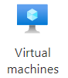

Universal controller



1.start/stop/Terminate Azure VM

2. Respond to Universal controller

3. Check Status /List Azure VM

4. Respond to Universal controller

# Managing Azure VM in Universal controller

## Integration Components

Below are the components involved in this integration and their details are as follows.

* **Universal controller:** 
  + Universal task – Azure VM is created in the universal controller and its integrated with Azure cloud platform through the REST API methods available for handling Azure VM’s
  + Through this Universal task the universal controller can perform the below operations in Azure Virtual Machines
    - start an Azure Virtual Machine
    - Stop an Azure Virtual Machine
    - Terminate an Azure Virtual Machine
    - Check the status of an Azure Virtual Machine
    - List the Azure VM’s belongs to a subscription & Resource group
* **Azure Virtual Machine API**
* There is no involvement of Azure python module in this integration, Direct REST API calls are made to the Azure Platform
* All the API calls are securely authenticated through Oauth2.0 authentication mechanism as stated by Microsoft
* The Authentication mechanism for oauth2.0 can be handled by a separate web services available in universal controller
* Bearer access token for azure will be expired every hour, so you may schedule the webservice task to refresh the access token accordingly.
* For the initial integration and setup, the new bearer access produced by webservices task will get in to universal global variable and for each of the azure VM function you may need to supply that global as input for authentication to be handled appropriately.
* In further section there will be more details on setting up the oauth2.0 authentication mechanism using webservices task
* All virtual Machine API URL’s can be referred in the link : <https://docs.microsoft.com/en-us/rest/api/compute/virtualmachines>

## Implementation Details

Details about the universal tasks for Azure VM as below:

* Universal task uses requests module in python
* Accepts input parameters like Azure VM Name, Azure Resource group, Azure Subscription, AZURE API Version & Oauth2.0 access token global variable Name have to mentioned as input.
* Information regarding Microsoft oauth2.0 authentication can be referred in the URL : <https://docs.microsoft.com/en-us/azure/active-directory/develop/v2-oauth2-auth-code-flow>
* Universal controller hosted environment should be able to post the message to Azure cloud platform.
* The Universal Task supports both Universal Agent for Linux/Unix and Windows.

# Installation

## Software Requirements for Linux Agent

**Universal Task name:**  Azure VM start/stop/terminate/check status/list VM’s

Requirements:

* Python 3.6
* For Python the following modules are required:
  + *sys, for system-specific parameters and functions*
  + *requests, to interact with a Azure Cloud via Api calls*

***Note: Please check requests python library is available already, if not then it needs to be added via python installer***

* *pip install requests*
* Universal Controller V6.4.7.0 or higher
* Universal Agent V6.5.0.0 or higher installed on a Linux/Windows Server

## Installation Steps

The following describes the installation steps:

1. **Check the current Python Version**

*python -V (Note: Capital “V”)*

If your Version is Python 3.6 or later all is fine. If a no python or a lower Version has been installed upgrade your python Version or install the Universal Agent with the Python binding option (--python yes). This option will install python 3.6. along with your universal agent.

e.g.

sudo sh ./unvinst --network_provider oms --oms_servers 7878@xxx.xxx.xx.xx --oms_port 7878 --oms_autostart no --ac_netname OPSAUTOCONF --opscli yes --python yes

1. **Add the required python modules**

In a command shell run as sudo or root:

* For Python the following modules are required:
* *pip install requests*

*or in case of universal Agent with python binding:*

*/opt/universal/python3.6/bin/python3 -m pip install requests*

Only run these if not available already:

* *pip install sys*

Note:

It is assumed that the modules logging, sys, datetime, os are already available. If not install them via pip. Only the module *requests* are not part of your installation.

1. **Import Azure VM Start-Stop-Terminate task including the Universal Template to your Controller**

Go to “All Tasks” and load via the Import functionality the Universal Tasks configuration into the Controller.

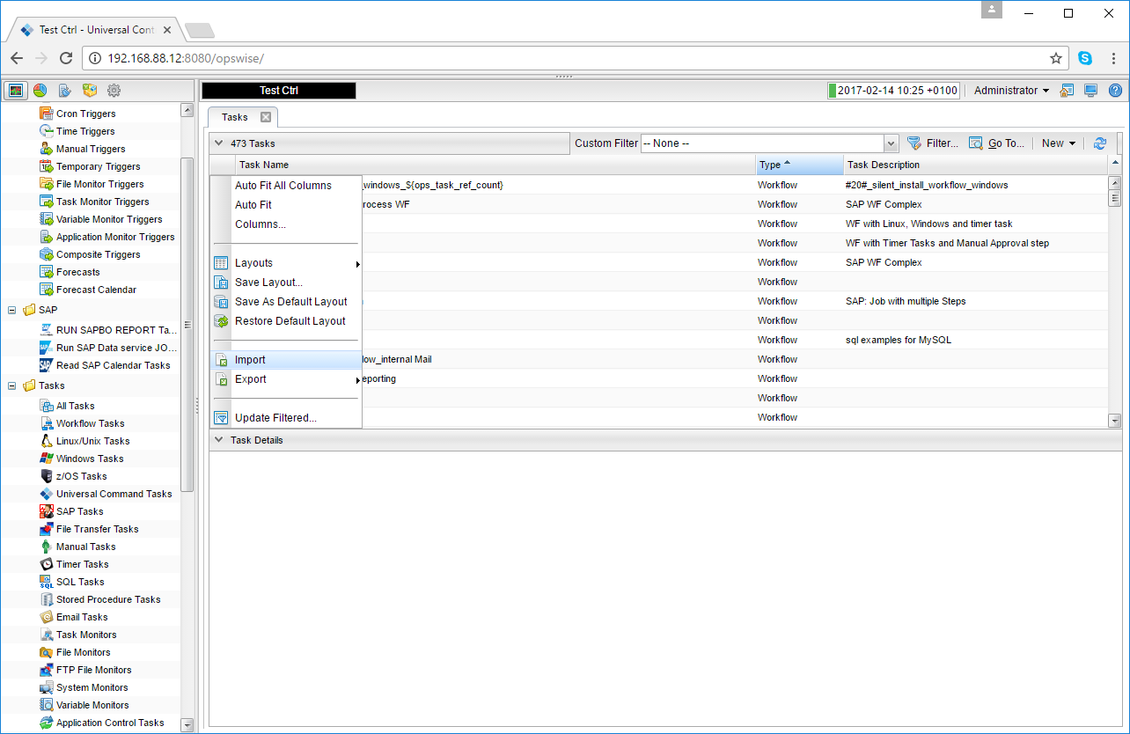 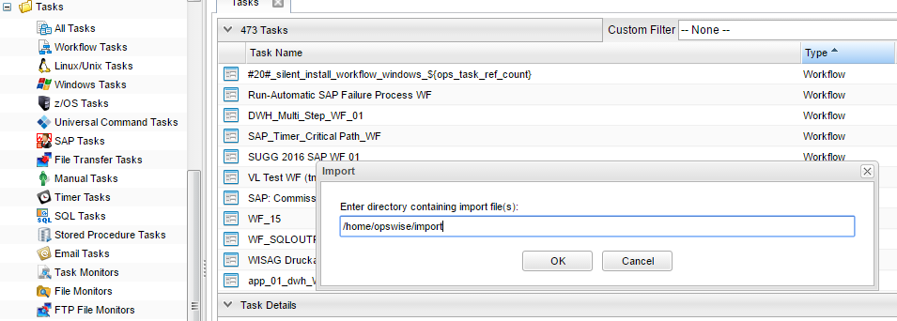

# Universal Task Configuration

1. **Starting an Azure Virtual machine from Universal controller:**

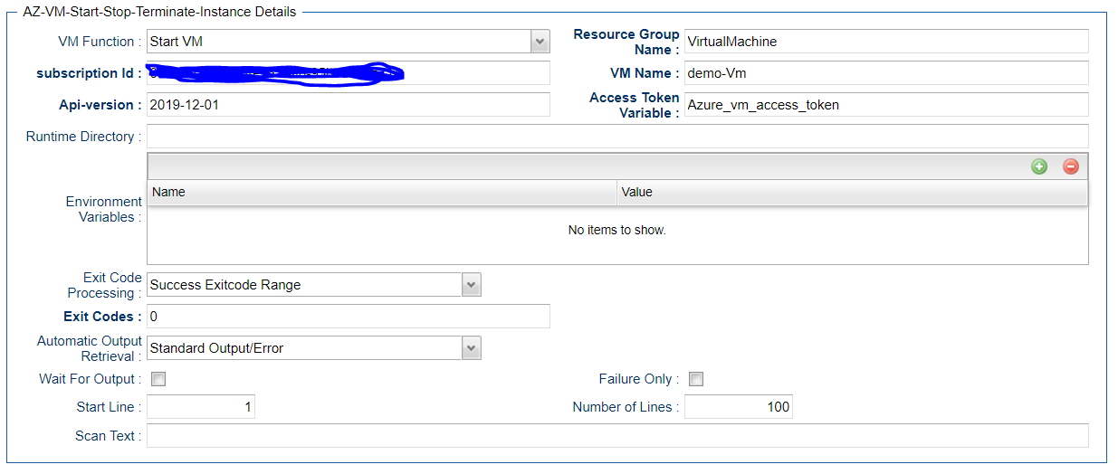

1. **List All VM’s for an Azure Subscription:**

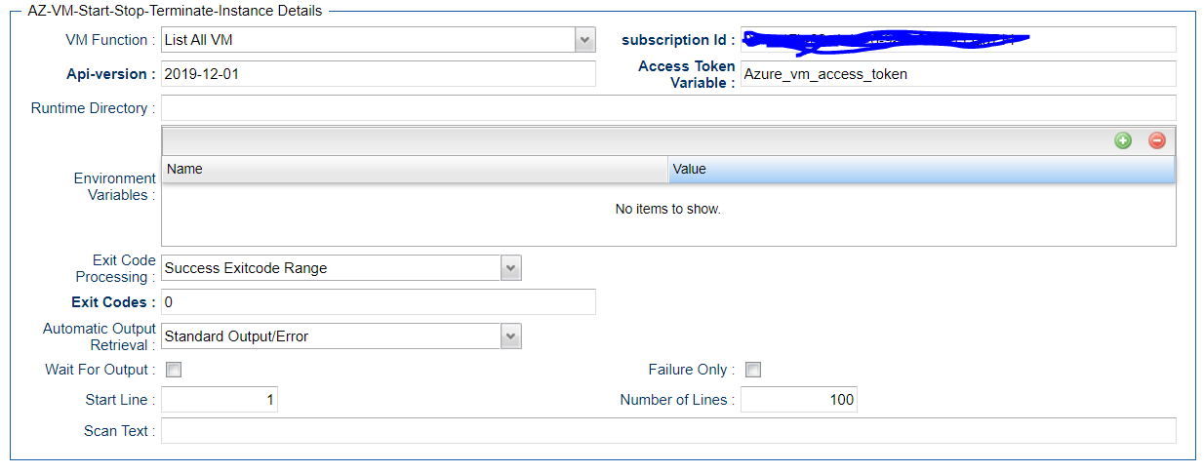

# Universal Tasks for AZ-VM-Start-Stop-Terminate-Instance

The following contents describes the Azure VM integration through the universal task.

| UT Name | Description |
| --- | --- |
| Azure VM Management | Schedule, Trigger & Monitor Azure VM Start/stop/terminate/Check status & List VM Funtionality |

## Trigger Azure VM Management

Triggering an Azure VM Start/stop/terminate/Check status/List VM process from universal controller based on the below input parameters

**Field Description:**

|  |  |
| --- | --- |
| Field | Description |
| VM Function | Select the function to perform with the Azure VM , Either start or stop or terminate or check status or List VM’s |
| Resource Group Name | Resource group name from the Azure Subscription |
| subscription Id | Azure Subscription ID |
| VM Name | Name of the Virtual Machine in Azure |
| Api-version | Api version in Azure |
| Access Token Variable | Bearer access that is store Universal controller global Variaböe |

Note: Access token is generate using the webservice task as below

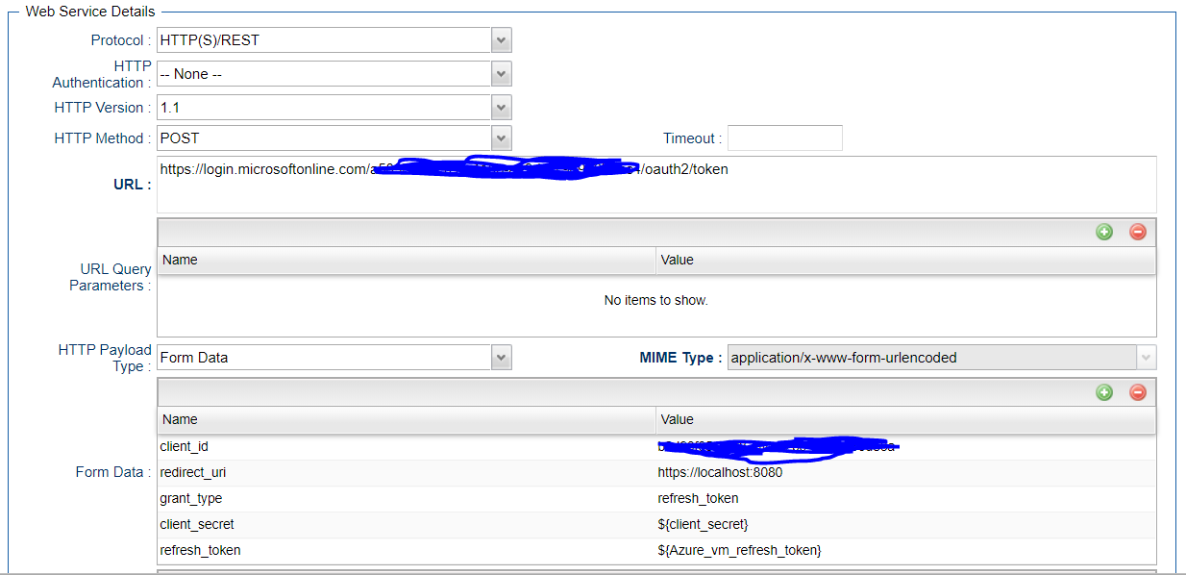

Generated Access token can be stored in a global variable by using the UAC function for the above webservices task in actions🡺set Variable

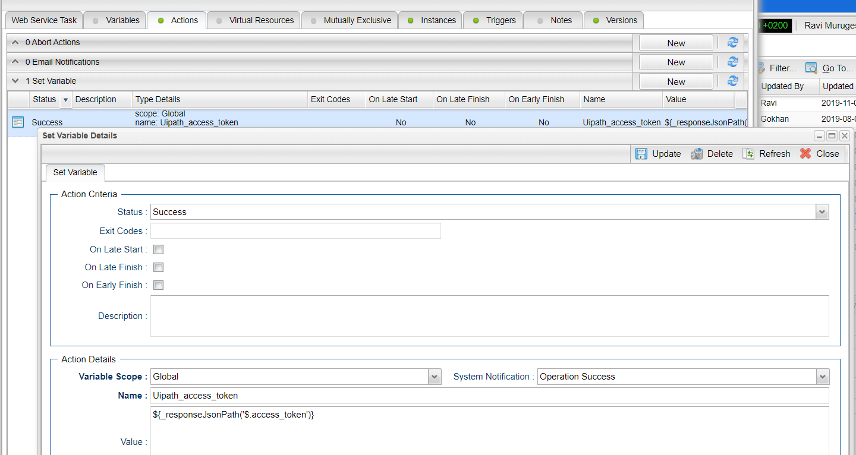

# Document References

This document references the following documents:

|  |  |
| --- | --- |
| Ref# | Description |
| 1. Azure VM | <https://docs.microsoft.com/en-us/rest/api/compute/virtualmachines> |
| 1. Azure Oauth2.0 | <https://docs.microsoft.com/en-us/azure/active-directory/develop/v2-oauth2-auth-code-flow> |
| 1. requests | <https://pypi.org/project/requests/#description> |
| 1. Universal controller API | <https://docs.stonebranch.com/confluence/display/UC67/RESTful+Web+Services+API> |